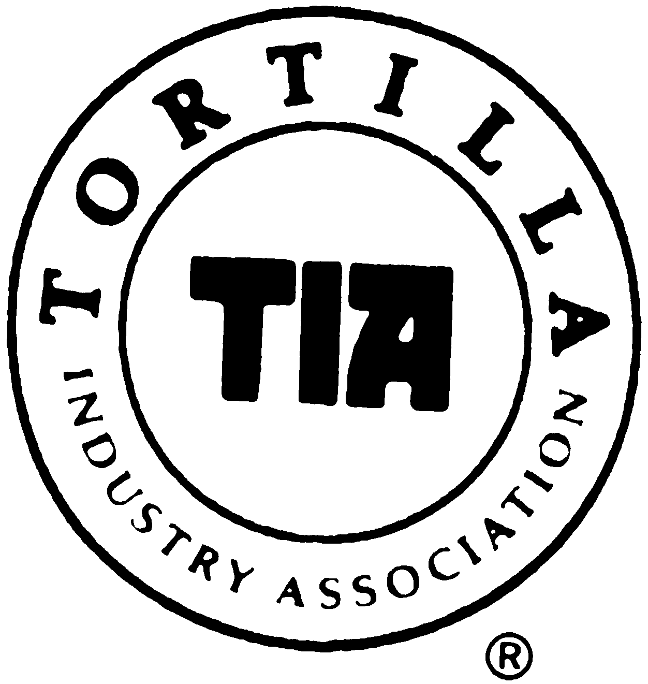

“Ask The Experts”

Please Write Your Question For TIA’s Panel of Experts To Answer For You
MEMBERS: please send this form to jkabbani@ tortilla-info.com for a rapid response
NON-MEMBERS: please bring with you to the next TIA event
ALL TOPICS WLECOME – E.G. Tortilla Quality, Plant Operation, Pricing & Profitability, Ingredients, Equipment Use, etc

